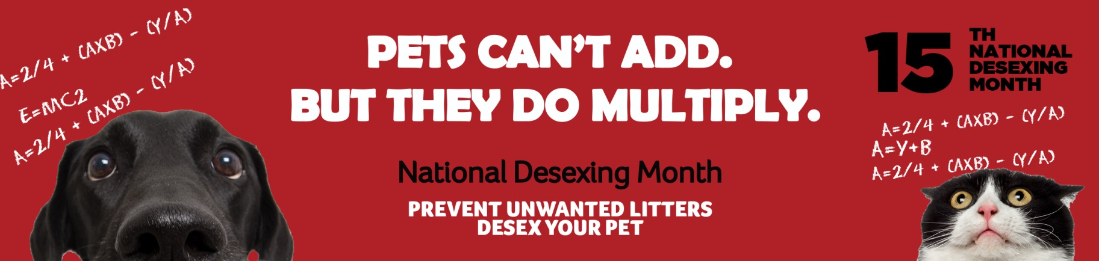

MEDIA RELEASE
For Immediate Use

PETS CAN’T ADD BUT THEY DO MULTIPLY.
It’s the 15th National Desexing Month in July 2019 and <name of Council> is urging residents to desex their pets, particularly cats, before the long breeding season in the warmer months.
<Name, job title> says that we all know dogs and particularly cats can multiply far faster than humans who can offer them homes.
“We’re urging as many pet owners as possible to take advantage of the discounted rates provided by the participating vet clinics in our area, which include <contact local vets to see who is participating in National Desexing Month and list them here>.
“Managing unwanted litters is a huge cost to the community, as well as stress to the animals and the people who have to manage them,” says <name, job title>.
National Desexing Month was developed by Animal Welfare League Queensland in 2005.
Since 2005, information and posters have been sent out to every vet, Council and animal organisation in Australia every year, to encourage community-wide promotion and support for desexing of cats and dogs before the spring breeding season.
The themed posters for this year feature images of a confused cat and dog trying to calculate how many kittens and pups they can produce.
Dr Joy Verrinder, AWLQ National Desexing Network Strategic Director, says cats have, on average, 10 kittens each year and if these kittens also have 10 kittens each year, the formula for 5 years looks something like this: Missy x 10 + (M x 10 x 10 ) + (M x10 x10 x10) + (M x10 x 10 x 10 x 10) + (M x10 x 10 x 10 x 10 x 10). That’s 1 + 10 + 100 +1000 + 10 000 + 100 000 = 111,111 kittens born from one undesexed cat in just 5 years.
“Councils can play a critical role in reducing the number of unwanted litters. Increasingly Councils are starting to budget for ongoing subsidised NDN Cooperative Desexing Programs which run all year round to help residents in need.
“Promoting desexing through special prices for every cat or dog owner in July is another important initiative and we are very thankful for vets and Councils who provide support,” says Dr Verrinder.
Key statistics:
- Last year 227 vet clinics around Australia participated by offering low cost desexing. Many Councils and vet clinics also utilised the posters to promote desexing in their communities.
- Approximately 13,000 cats and dogs were desexed in just one month as a result of the National Desexing Month campaign.
- This represents an increase of approximately 3000 desexing operations from each of the previous two years.
Cat and dog owners can find out what special offers are available near them by accessing the National Desexing Network website at www.ndn.org.au from the last week in June.
-- ENDS --

For further information or interview opportunities with <name of Council> please contact:
<Name>
<Job Title>
<Phone>
For further information or interview opportunities about National Desexing Month please contact:
Dr Joy Verrinder
Strategic Director
0417 788 063
For further information or interview opportunities with Animal Welfare League Queensland please contact:
Craig Montgomery
Public Relations & Communications Manager
0424 382 727

